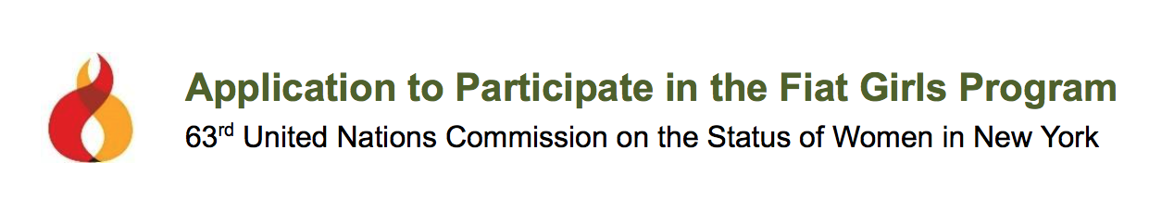
PLEASE COMPLETE THIS APPLICATION AND EMAIL TO MRS. HOWARD AT: universalfiat@gmail.com
FIAT GIRLS HIGH SCHOOL PROGRAM APPLICATIONS DUE BY SEPTEMBER 15th
FIAT GIRLS COLLEGE PROGRAM APPLICATIONS DUE ASAP (SUMMER OF 2018)
All accepted participants must attend a 2 hour group video conference orientation in January (to be scheduled via email)

UN Session in New York: March 9-14, 2019

Applicant Information
Name
Street Address
City, State, Zip
Student Email
School
Grade Level
Age in March, 2017
Parent Contact Information (high school only)
DO YOU HAVE OR HAVE YOU HAD any physical, emotional, behavioral, or academic concerns (i.e. epilepsy, anxiety disorder, ADHD, etc.)*
Would you consider yourself introverted or extroverted? (for room assignment and grouping purposes)
*This is an academically and socially intense experience. If you have any chronic health or academic issue, it is important that I know ahead of time to ensure effective preparation on my end, and to maximize your experience as well as that of the other participants.

Who were you nominated or referred by? Please provide name and contact information. (examples include Campus Minister, Youth Minister, Spiritual Guide, School Administrator, Fiat Administrator or Veteran)

Why does this opportunity interest you? What do you hope to learn or achieve through this experience?

Do you have a religious affiliation? If so, what is it? Are you active in your faith life, and if so, how?

Do you have a basic understanding of the Catholic Church’s position on the dignity of the human person? If you do, what are your thoughts on it as it relates to artificial birth control? (This question is not designed to exclude you from the program based on whether you agree or not. It is a means to discern the depth of your critical thinking skills with regard to a fundamental concept we encounter at the UNCSW.)

Agreement and Signature--

By submitting this application, I affirm my desire to participate in the Fiat Girls Program. I understand that if I am selected as a Fiat Girl, I will be expected attend the 2-hour group video conference orientation in January, and to participate in the 2019 March conference. I further understand that failure to complete assigned program requirements may result in dismissal from the program.
Student Signature
Parent Signature (high school only)
Date

Thank you for your interest in becoming a Fiat Girl!
Girls will be selected and notified on a rolling admission basis until all spots are filled.

FIAT GIRLS HIGH SCHOOL PROGRAM: Upon acceptance, you will be asked to complete the Consent Form and Liability Waiver, and to submit the initial deposit of $500, due immediately.

FIAT GIRLS COLLEGE PROGRAM: Upon acceptance, you will be asked to complete the Personal Release Form and Liability Waiver, and to submit the initial deposit of $600 by September 1, 2018.

